IMMIGRATION TO CANADA QUESTIONNAIRE
Please, answer all questions, clearly printed or typed.


YOUR Name M Asad Ali

Phone Number | 03016538070 | Alternate No.
00 030


Email Address asadkhokhar04@gmail.com

Mailing address House #15/132, Street CH. Imam Din Mohallah Chiragh Pura,Sialkot ,Sialkot.

Your Date and Place of Birth. 13-09-1993


Marital Status. Single


YOUR SPOUSE

Name of your Spouse.


Spouse’s Place and Date of

Birth

Qualification of your Spouse

Occupation of your Spouse

Number of Children

Names, dates of births and education

details of children:

Relative in Canada? [Relationship] No

Personal Information

Your Education
 | Education |  | No of Years |  | Duration To-From |  | Certification
 |  |  |  |  |  |  | with Major
 | Secondary / High School  Quaid e Azam Public school, Sialkot |  | 2 years |  | 2009-2011. |  | Computer science,Chemistry,Physics


Technical.

ILM COLLEGE,SIALKOT 2 YEARS 2011-2013 Mathmetics,Chemistry,Physics

MIRPUR UNIVERSITY OF. 4 years. 2013-2017 SOFTWARE ENGINEER
SCIENCE AND TECHNOLOGY
,MIRPUR AJK , PAKISTAN
Education of your Spouse
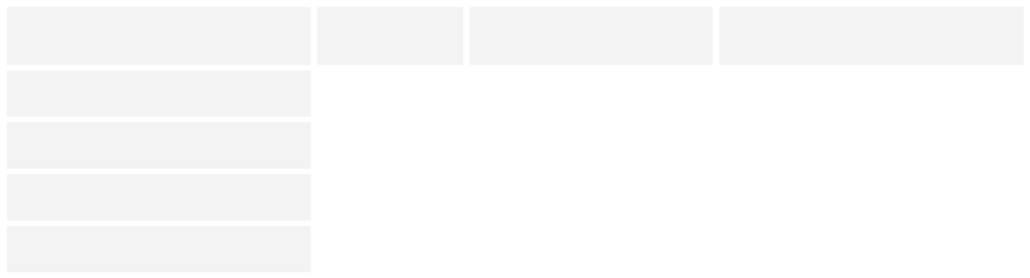

Education

No of Years

Duration To-From

Certification
with Major

Secondary / High School

Technical

College

University

Your Current Employment


Position/job title: Software Quality Engineer


Duties/responsibilities: Manual and Automation testing of web and mobile
Applications.

Dates of employment:[ From – To] September 2017 to Present.

Name of employer: Muhammad Tahir

Type of business: CCJK TECHNOLOGIES, SOFTWARE HOUSE,

Location: New Garden Town, Lahore

Your Previous Employment(s)

Position/job title:


Duties/responsibilities:

Dates of employment:[ From – To]

Name of employer:

Type of business:

Location:

Spouse’s Current Employment


Position/job title:

Duties/responsibilities:

Dates of employment:[ From – To]

Name of employer:

Type of business:

Location:


What amount of funds is available for transfer to Canada (in

Canadian or US Dollars):
10 thousands Canadian dollars

Your net worth including the net worth of your spouse and dependent children but excluding personal motor vehicles and personal jewelry in Canadian or US Dollars

Do you have the result of I.E.L.T.S.? (in Process)
OR How would you rate your English and / or French Proficiency?

Component |  |  |  | Moderate |  | Basic

Listening


Speaking

Reading

Writing

International Travel Details, if any: NO

Please provide names of countries visited.

